

**Update: Estimating child care supply and demand in Texas**

May 8, 2020



**Purpose**

The Texas Workforce Commission (TWC) seeks to understand the need for child care among workers given the current COVID-19 pandemic. This will help TWC support the work of the Governor’s Frontline Child Care Task Force and Strike Force to Open Texas understand the underserved areas of the state that might be in need of a greater child care supply.

**Approach and key assumptions**

Our estimates build on our previous analysis by gathering data at the county level (as opposed to Metropolitan Statistical Areas (MSA)/ Core-based statistical areas (CBSA)). We have also adjusted estimates to reflect businesses that are open in the first phase of reopening (as of May 1, 2020). We relied on the following data sources and assumptions:

**Supply of child care seats during the COVID-19 pandemic**

* Data provided by TWC from the Frontline Operation list as of May 5, 2020, which indicates the location of child care providers that are currently open.
* We merged the Frontline Operation list with publicly available data from Child Care Licensing to gather total licensed capacity of each child care program currently open in Texas. Research on industry standards suggests that viable child care programs, on average, aim to have enrollment rates at ~85% of licensed capacity.[1] Hence, we use 85% of licensed capacity as an estimate of the actual capacity, and refer to it as pre-COVID available seats below.
* We created three scenarios for available child care seats:
  + High: 70% of pre-COVID available seats
  + Medium: 50% of pre-COVID available seats
  + Low: 35% of pre-COVID supply. This is based on a foot traffic data we have analyzed suggesting that child care enrollment is ~25% of what it was pre-COVID.[2] We assume child care providers can serve more children than current enrollment suggests, but only at 35% of pre-COVID levels.
* For child care homes that remain open, we assume that all pre-COVID available child care seats are available now given that staffing changes do not impact this segment of child care providers.

**Demand for child care among current workforce**

* We utilized population data by county from the Census and American Community Survey 1-year estimates (2018), including estimates for the total number of people in the workforce by industry and occupation. We applied the following assumptions:
  + We selected industries and occupations relevant to this analysis, beginning with essential industries and adding those recently reopened at reduced capacity. Workforce estimates by industry are higher than estimates by occupation, so we consider estimates by industry the upper bound of potential demand estimates. Please see the appendix for industries and occupations included.
  + We take a county’s population and total number of households to estimate the average number of people per household. We assume that households from our industries of interest follow these typical figures and estimate the total number of households with workers in our industries of interest.
  + Census provides the proportion of the population younger than 18 years old in each county. Assuming uniform distribution across ages younger than 18, we estimate the percent of the population 12 years old or younger. We use this to estimate the number of children under age 12 per 100 households.
  + We estimate the number of children who may need child care in our industries of interest by utilizing the number of households with workers in these industries and the rate of children under age 12 per 100 households.
  + We adjust for whether or not households contain other non-working adults or older sibling that can provide care for some children in the household. We do this using Current Population Survey (Census and Bureau of Labor Statistics) data on the proportion of workers who do not have other adults/ older children in the home or who are single parents.
* Given that the first phase of reopening businesses in Texas requires limited occupancy (25%) for certain industries (e.g., restaurants, retail, movie theaters) we adjusted workforce estimates in an attempt to account for lower staffing levels. We assume 70% of the pre-COVID workforce in these industries based on foot traffic data to locations collected by SafeGraph. This data is collected from to pings to cell phone that contain apps with the capacity to provide gps location. To arrive at our figures, we assume that in the first week of March, the locations were operating at normal (“full”) capacity. We then observe the week with the lowest foot traffic and we assume that this is foot traffic at 0% capacity in terms of serving customers locally. For a restaurant, for example, this is the foot traffic consistent with picking up orders to go but not serving any client in the restaurant itself. We then identify the amount of employment in these sectors at 0% capacity (as defined above). We then correlate the amount of employment with foot traffic at “full” capacity and at zero capacity and interpolate linearly to 25% capacity. In the coming weeks, we plan to keep updating and improving on this forecast model.
* Our analysis does not take into account current data on unemployment as this situation is changing very fast. However, it is likely that our foot traffic data reflects some of the changes in unemployment. We plan to update the model to include employment, and to construct a model to forecast changes in unemployment.

**Current estimates**

For simplicity, the below summary utilizes the upper range for demand estimates, focusing on workforce estimates by industries rather than occupations. When looking at the size of the workforce by industry rather than occupation, the total population is larger for nearly all counties. The attached spreadsheet and customizable dashboard[3] we created allows for adjusting both supply and demand scenarios to consider various possibilities, including estimates by occupation instead of industry.

**Low child care supply scenario**

Consistent with other approaches to estimate availability of child care[4], we have defined limited availability as fewer than 35 seats per 100 children. When considering children of workers for industries operating in the first phase of reopening, in the “low” supply scenario, 159 counties (63%) have fewer than 15 seats per 100 children, while 82 counties (32%) have 15-35 seats per 100 children.[5] Only two counties (both extremely small) have at least 35 child care seats per 100 children:

* Concho County
* Stonewall County

**Medium child care supply scenario**

In the “medium” supply scenario, 139 counties (55%) have 15-35 child care seats per 100 children and 96 (38%) of counties have fewer than 15 seats per 100 children. While the majority of these 96 counties with particularly constrained supply in this scenario are very small, four counties are home to at least 2,000 children of workers who likely need child care

* Hays County
* Starr County
* Travis County
* Webb County

In the “medium” supply scenario, only eight counties have at least 35 seats per 100 children. With the exception of Rockwall County, these are all very small counties and have very small numbers of children who may need child care.

**High child care supply scenario**

When considering children of workers for our industries of interest in the first phase of reopening, in the “high” supply scenario, 117 counties (46%) have 15-35 seats per 100 children and 52 counties (20%) have at least 35 seats per 100 children. Even in the “high” supply scenario, 74 counties (30%) have particularly constrained supply, with fewer than 15 seats per 100 children. Again, while the majority of these 74 counties are very small, two of these are home to at least 2,000 children of workers who likely need child care:

* Starr County
* Webb County

**COVID-19 observations**

As requested, we have included publicly available COVID-19 data by county from the Texas Department of State Health Services[6] in this analysis (see spreadsheet and dashboard). We looked for geographies that appear to be both strained in terms of child care capacity and COVID-19 cases. Only one county, Webb County, has:

* At least 300 COVID-19 cases;
* Fewer than 15 seats per 100 children of workers who likely need child care (in both the medium and high child care supply scenarios) and
* At least 1,000 children of workers who likely need child care

Webb County has 414 cases, 15 seats per 100 children (even in the high supply scenario), and ~14,000 children of workers who likely need child care.

While supply is not as constrained as Webb County, the below eight counties are experiencing the following:

* At least 500 COVID-19 cases;
* 15-25 seats per 100 children of workers who likely need child care (in both the medium and high child care supply scenarios) and
* At least 5,000 children of workers who likely need child care
  + Dallas County
  + El Paso County
  + Tarrant County
  + Travis County
  + Bexar County
  + Harris County
  + Montgomery County
  + Potter County

**Appendix**

**Child Care Seats per 100 children:** Medium supply scenario, demand estimated by industry (upper bound)[7]

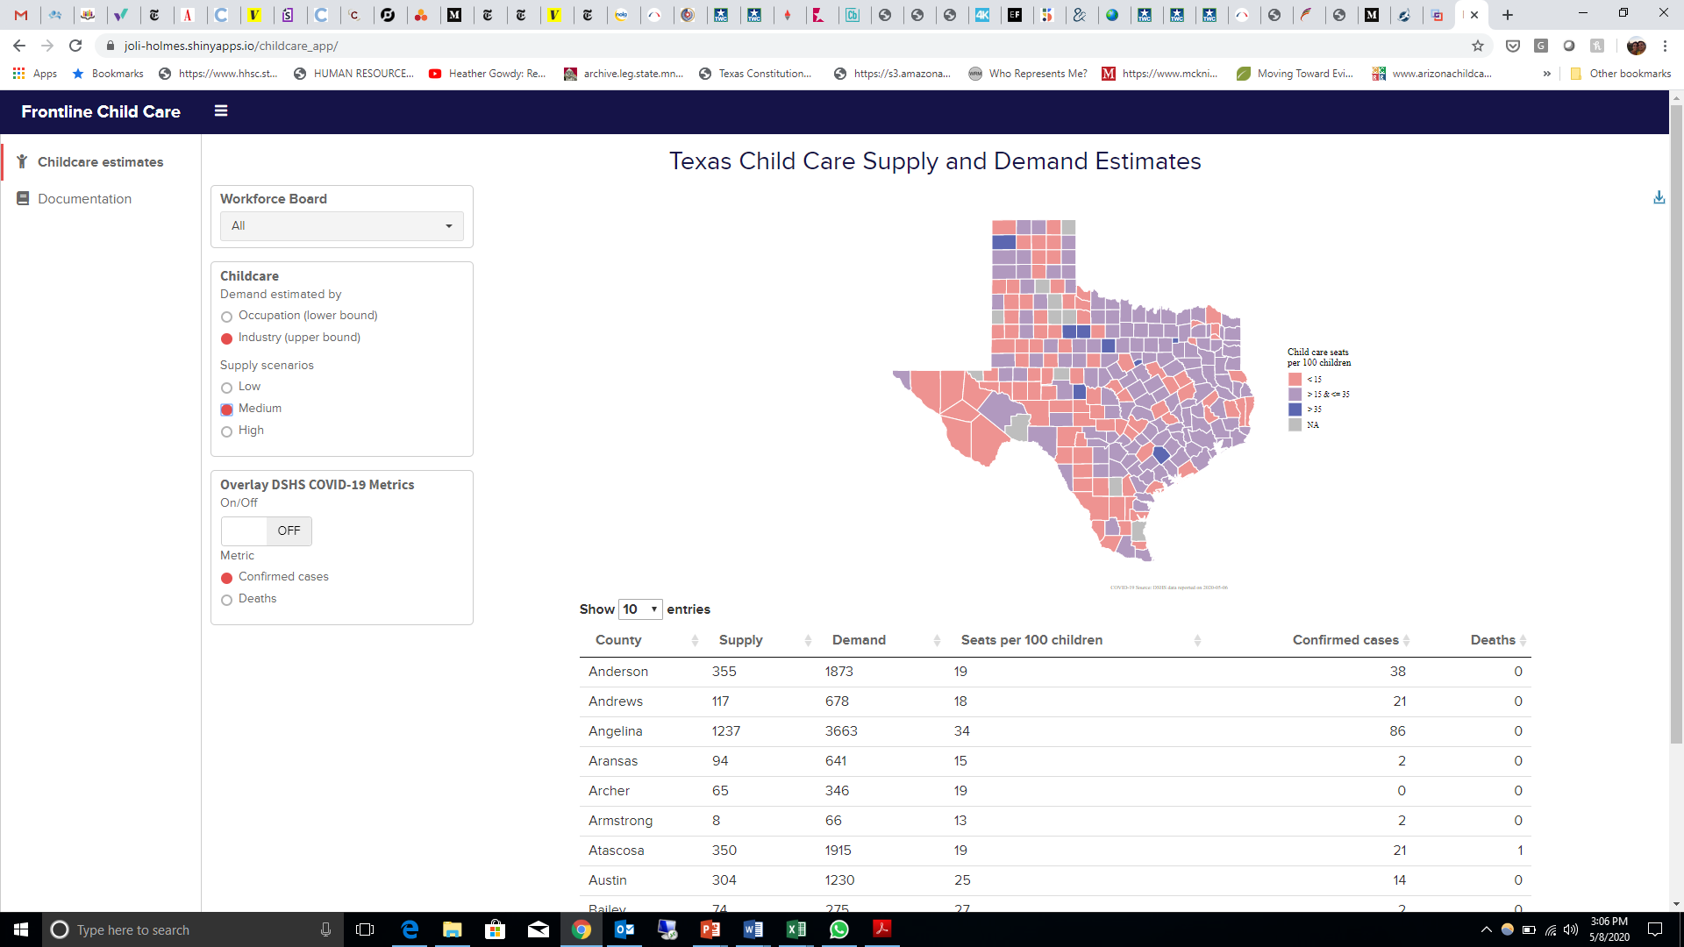

**Child Care Seats per 100 children and COVID-19 cases by county:** Medium supply scenario, demand estimated by industry (upper bound)

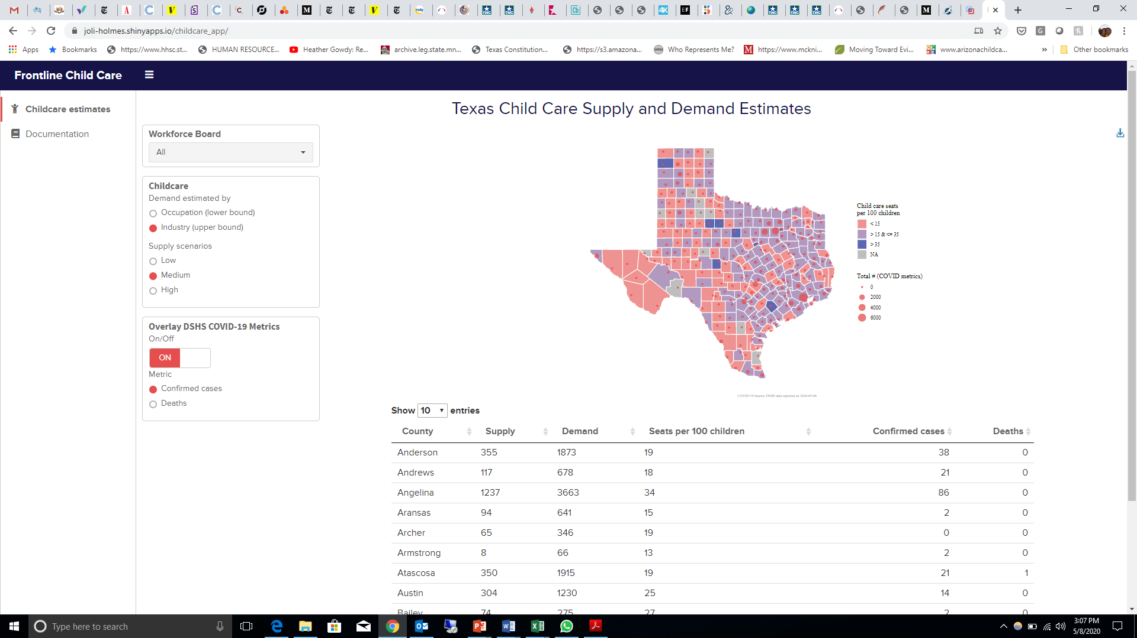

**Essential industries included in demand estimates**

* Health Care & Social Assistance
* Manufacturing
* Educational Services
* Professional, Scientific, & Technical Services
* Transportation & Warehousing
* Administrative & Support & Waste Management Services
* Wholesale Trade
* Public Administration
* Information
* Utilities

**Industries re-opening phase 1 (at 25% occupancy) added to essential industries:**

* Retail trade and arts
* Entertainment and recreation
* Accommodation & food services

**Essential occupations included in demand estimates**

* Transportation Occupations
* Installation, Maintenance, & Repair Occupations
* Farming, Fishing, & Forestry Occupations
* Community & Social Service Occupations
* Education Instruction, & Library Occupations
* Law Enforcement Workers Including Supervisors
* Fire Fighting & Prevention, & Other Protective Service Workers Including Supervisors
* Health Diagnosing & Treating Practitioners & Other Technical Occupations
* Personal Care & Service Occupations
* Health Technologists & Technicians
* Building & Grounds Cleaning & Maintenance Occupations
* Healthcare Support Occupations

**Occupations re-opening phase 1 (at 25% occupancy) added to essential occupations:**

* Sales and related occupations
* Arts, Design, Entertainment, Sports, & Media Occupations
* Food Preparation & Serving Related Occupations

1. <https://childcareta.acf.hhs.gov/sites/default/files/public/241_1411_pcqc_ece_characteristics_final.pdf>
2. Professor Flavio Cunha, one of the Lab’s Faculty Affiliates, has secured access to de-identified cell phone data owned by SafeGraph. This data allows researchers to observe the amount of mobility in each Public Use Microdata Area. This mobility data is highly correlated with economic activity. We are building a model to link economic activity with childcare needs.
3. <https://joli-holmes.shinyapps.io/childcare_app/>
4. <https://catriskprod.wpengine.com/texas-child-care-desert-methodology/>
5. Note that estimates were not made for 11 very small Texas counties for which data on child care supply is not available from state sources.
6. <https://txdshs.maps.arcgis.com/apps/opsdashboard/index.html#/ed483ecd702b4298ab01e8b9cafc8b83>
7. See dashboard for additional customization: <https://joli-holmes.shinyapps.io/childcare_app/>